Award Nomination Form

“Breaking Barriers: Life Beyond Labels”
Deschutes County Convention Center
3800 SW Airport Way
Redmond, OR 97756
April 24, 2024
Submission Deadline: April 1, 2024
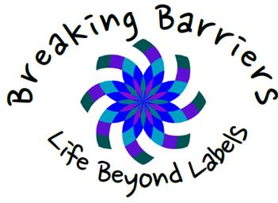

Please fill out this form to nominate someone for the award. There are 4 categories: Educator, Service Provider, Advocate, and Life-Time Achievement. You can nominate an individual or an organization. Please explain how they are breaking barriers in the community. You must be available to present the award on conference day!
Please fill out the following information about yourself as the person nominating an award.

Full Name:
Address:
Phone:
Email Address:
Your Role: | Family Member  Educator  Service Provider  Self- Advocate

Please provide the following information about the person/organization that you are nominating.

Please select a category for the Nominee
Educator Service Provider Advocate Life-Time Achievement.
First/Last Name:
Organization:
(if applicable)
Phone Number:
Email:
Address:
How did this person or organization break barriers

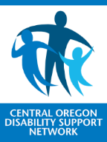
Please email this form to info@codsn.org or mail it to:
CODSN 2525 NE Twin Knolls Drive, Suite 7, Bend, OR 97701

For additional information contact: Dianna Hansen Phone: (541) 548-8559

